What will we be learning?  Paper 1  Section 1 – Applied Anatomy and Physiology | Why this? Why now?  GCSE PHYSICAL EDUCATION  SECTION 1 (PAPER 1)  This unit is taught in Year 10 for paper 1 but will also link as a synoptic topic to paper 2 in Year 11.  Some of this content also links into your AEP written coursework.  You will develop knowledge and understanding of the basic structures and functions of body systems that are particularly important to physical activities and sports. You will also study the short and long-term effects of exercise on these systems, and how these effects can impact on physical fitness and performance. You will develop the ability to collect and use data, analyse movement, and apply their knowledge and understanding, using examples from physical activity and sport. | Key Words:  Synovial joint  Articulating  Extension  Flexion  Rotation  Abduction  Adduction  Circumduction  Ligaments  Tendons  Cartilage  Agonist  Antagonist  Prime mover  Origin  Insertion  Fixator  Mechanical advantage  Axes  Planes  Cardiovascular  Haemoglobin  Vasodilation  Vasoconstriction  Heart rate  Stroke volume  Cardiac output  Trachea  Epiglottis  Oxyhaemoglobin  Breathing rate  Inspiration  Expiration  Tidal Volume  Minute ventilation  Aerobic  Anaerobic  Lactic acid  Metabolism  Anticipatory rise  Adrenaline  Vascular shunt mechanism  Hypertrophy  Blood viscosity  Osteoporosis
What will we learn?
Section 2 - Applied Anatomy and Physiology
  - The structure and function of the skeletal system
- Location of the major bones
- Functions of the skeleton
- Types of synovial joints
- Types of movement at hinge joints and ball and socket joints
- Other components of joints (ligament, cartilage, tendons)
  - The structure and function of the muscular system
- Location of major muscle groups
- The roles of muscle in movement
  - Movement analysis
- Lever systems
- Planes of movement and axes of rotation
1.4 The cardiovascular and respiratory system
- Structure and function of the cardiovascular system
- Structure and function of the respiratory system
- Aerobic and anaerobic exercise
  - The effects of exercise on the body
- Short-term effects of exercise
- Long-term (training) effects of exercise
What opportunities are there for wider study?
Sixth form studies
- Cam Tech Sport
- A level PE
Careers/degree courses
- Sports science
- Physiotherapy
- PE teacher
How will I be assessed?
- Paper 1 (worth 30%) – 60 marks – 60 minutes
- AEP Written coursework

- THE STRUCTURE AND FUNCTION OF THE SKELETAL SYSTEM  Location of the major bones  - Know the name and location of the following bones in the human body: Cranium, Vertebrae, Ribs, Sternum, Clavicle, Scapula, Pelvis, Humerus, Ulna, Radius, Carpals, Metacarpals, Phalanges, Femur, Patella, Tibia, Fibula, Tarsals, Metatarsals.  Functions of the skeleton  - Understand and be able to apply examples of how the skeleton provides or allows: support, posture, protection, movement, blood cell production, and storage of minerals.  Types of synovial joints  - Know the types of major joints (hinge and ball and socket) and articulating bones (bones that make up the joints) in the knee, elbow, shoulder, and hip.  Types of movement at hinge joints and ball and socket joints  - Know the types of movement at hinge joints (flexion and extension), as well as ball and socket joints (flexion, extension, rotation, abduction, adduction, and circumduction).  Other components of joints (ligament, cartilage, tendons)  - Know the roles of: ligament, cartilage and tendons. | 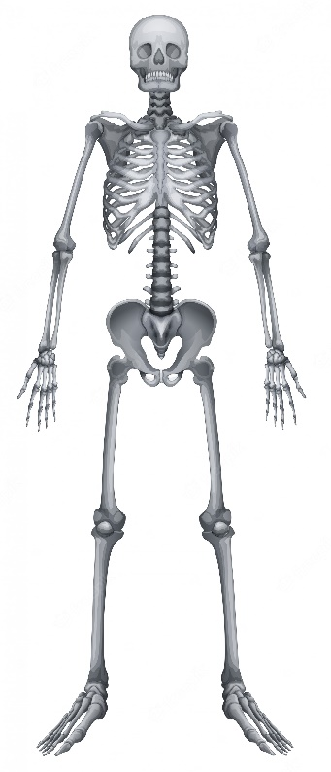
1.2 THE STRUCTURE AND FUNCTION OF THE MUSCULAR SYSTEM  Location of major muscle groups  - Know the name and location of the following muscle groups in the human body: Deltoid, Trapezius, Latissimus Dorsi, Pectorals, Biceps, Triceps, Abdominals, Quadriceps, Hamstrings, Gluteals, Gastrocnemius, and be able to apply their use to examples from physical activity/sport:  The roles of muscle in movement  - Know the definitions and roles of the following and be able to apply them to examples from physical activity/sport: agonist, antagonist, fixator, and antagonistic muscle action. | 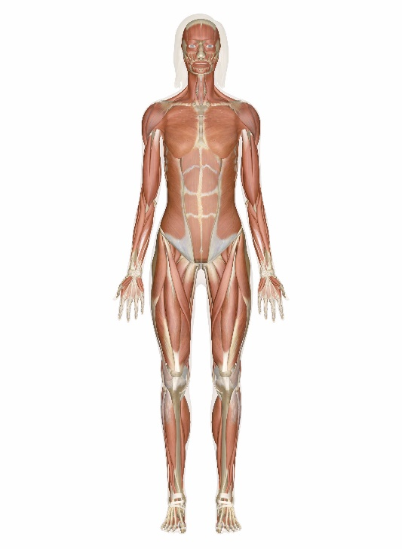
1.3 MOVEMENT ANALYSIS  Lever systems  - Know the three classes of lever and their use in physical activity and sport: 1st class (neck), 2nd class (ankle), and 3rd class (elbow).  - Know the definition of mechanical advantage.  Planes of movement and axes of rotation  - Know the location of the planes of movement (frontal, transverse and sagittal) and the location of the axes of rotation (frontal, transverse and longitudinal) in the body and their application to physical activity and sport. | 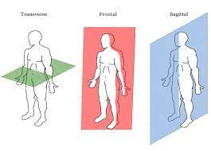  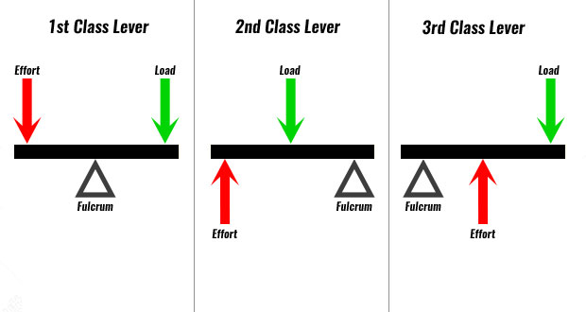
- THE CARDIOVASCULAR AND RESPIRATORY SYSTEM  Structure and function of the cardiovascular system  - Know the double-circulatory system (systemic and pulmonary) and the different types of blood vessel (arteries, capillaries, and veins).  - Understand the pathway of blood through the heart (atria, ventricles, bicuspid, tricuspid and semilunar valves, septum and major blood vessels (aorta, pulmonary artery, vena cava, pulmonary vein).  - Know the definitions of heart rate, stroke volume, cardiac output.  - Know the role of red blood cells.  Structure and function of the respiratory system  - Understand the pathway of air through the respiratory system (mouth, nose, trachea, bronchi, bronchiole, alveoli).  - Know the role of respiratory muscles in breathing (diaphragm and intercostals).  - Know the definitions of breathing rate, tidal volume, and minute ventilation.  - Understand about alveoli as the site of gas exchange.  Aerobic and anaerobic exercise  - Know the definitions of aerobic exercise and anaerobic exercise and be able to apply practical examples activities in relation to intensity and duration. | 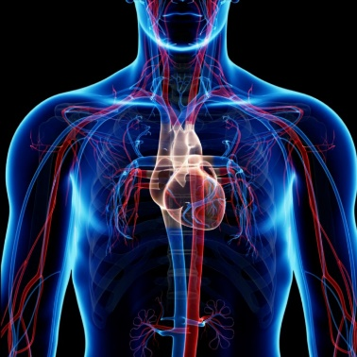  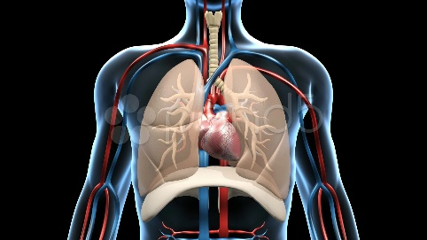
- SHORT AND LONG TERM EFFECTS OF EXERCISE ON THE BODY SYSTEMS  Short-term effects of exercise  - Understand the short-term effects of exercise on: muscle temperature, heart rate, stroke volume, cardiac output, redistribution of blood flow during exercise, respiratory rate, tidal volume, minute ventilation, oxygen to the working muscles, lactic acid production.  - Apply understanding of these effects to practical examples.  - Collect and use data related to short and long-term effects.  Long-term effects of exercise  - Understand the long-term effects of exercise on: bone density, hypertrophy of muscle, muscular strength, muscular endurance, resistance to fatigue, hypertrophy of the heart, resting heart rate and resting stroke volume, cardiac output, rate of recovery, aerobic capacity, respiratory muscles, tidal volume and minute volume during exercise, capillarisation.  - Apply understanding of these effects to practical examples.  - Collect and use data related to short and long-term effects. | 